**CC2: 727721EUIT181**

package com.cc2.testcc;

import org.openqa.selenium.By;

import org.openqa.selenium.Keys;

import org.openqa.selenium.WebDriver;

import org.openqa.selenium.firefox.FirefoxDriver;

import org.testng.Assert;

import org.testng.annotations.BeforeClass;

import org.testng.annotations.Test;

import io.github.bonigarcia.wdm.WebDriverManager;

public class Yatra {

private WebDriver driver;

@BeforeClass

public void setUp() {

WebDriverManager.firefoxdriver().setup();

driver = new FirefoxDriver();

}

@Test

public void testSearch() {

driver.get("https://www.yatra.com");

driver.manage().window().maximize();

driver.findElement(By.xpath("//*[@id=\"booking_engine_flights\"]")).click();

driver.findElement(By.xpath("//*[@id=\"BE_flight_form_wrapper\"]/div[1]/div[1]/ul[1]/li[2]/a")).click();

driver.findElement(By.xpath("//*[@id=\"BE_flight_arrival_date\"]")).click();

driver.findElement(By.xpath("//*[@id=\"22/04/2023\"]")).click();

driver.findElement(By.xpath("//*[@id=\"BE_flight_paxInfoBox\"]/span")).click();

driver.findElement(By.xpath("//*[@id=\"BE_flight_passengerBox\"]/div[1]/div[1]/div/div/span[2]")).click();

driver.findElement(By.xpath("//*[@id=\"flight_class_select_child\"]/ul/li[2]/span")).click();

driver.findElement(By.xpath("/html/body/div[2]/div/section/div[1]/div/div[1]/section/div/div/div/div[1]/div[3]/div[2]/div[1]/input")).click();

String aText = driver.findElement(By.xpath("/html/body/h1")).getText();

String eText = "Access Denied";

Assert.assertEquals(aText, eText);

}

}

**Output:**

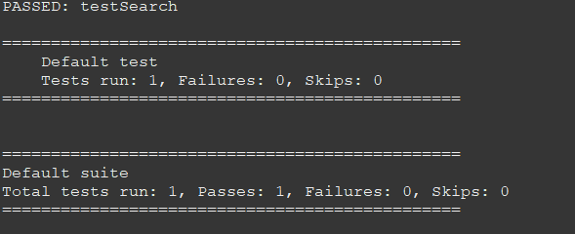

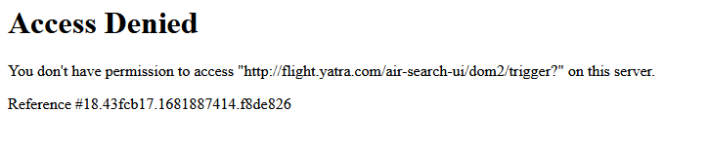

**Emailable Report:**

